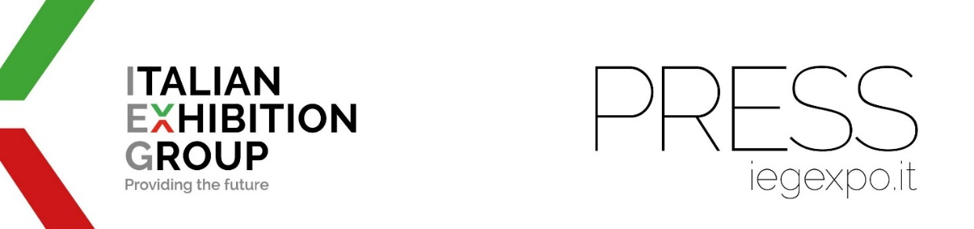

press release
(English translation)

IEG IS TAKING MADE IN ITALY ARTISAN GELATO TO CHINA

- From 10th to 12th May, with SIGEP CHINA 2023 in Shenzhen, 100 brands and dozens of excellent Italian artisan dolce foodservice companies in an area of the country with 86 million people

- The great SIGEP – the International Artisan Gelato, Pastry, Bakery and Coffee Trade Show - with the Rimini brand around the world

- Italian dolce foodservice art meets its Chinese equivalent: the Instagrammable gelato “phenomenon”

https://www.iegexpo.it/en | https://en.sigep.it | https://www.sigepcn.com/en

Italy/Rimini, 9th May 2023 - With 100 flagship brands of Made in Italy production excellence, representing the elite of Italian dolce foodservice art and association stakeholders, and an expected 20,000 visitors, the first edition of SIGEP CHINA, held at the Shenzhen World Exhibition & Convention Centre, starts tomorrow, 10th May 2023 (ongoing for three days). The opening ceremony will also be attended by Massimiliano Tremiterra, Trade Commissioner of the Italian Trade Agency (ITA) office in Canton, and Valerio de Parolis, Consul General for Italy in Guangzhou.

IEG CHINA’S ECONOMIC CATCHMENT AREA
Organised by Italian Exhibition Group through IEG China, in a crucial and strategic agreement with Koelnmesse, SIGEP CHINA aims to bring made-in-Italy gelato to the Land of the Dragon.
And it is doing so in Shenzhen, the economic engine of the Greater Bay Area of Guandong - Hong Kong - Macao, a reference point for the entire southern Chinese market, categorised as a “first class” city on a par with Beijing, Shanghai and Canton. A market of 86 million people, with a GDP that, according to the latest available data, is close to $1,700 billion. This globally competitive business location not only excels in finance and technology but also in tourism and is therefore a formidable development pole also for our country's artisan dolce foodservice industry.
But that’s not all. According to data from iiMediaResearch, in terms of regions, 46.1% of gelato consumers reside in eastern and southern China, making the Greater Bay Area a particularly attractive location for Italian companies in the sector.

EXHIBITION AND EVENTS
The SIGEP CHINA exhibition route will wind its way through raw materials and ingredients, machinery and equipment, packaging and services for five different dolce foodservice sectors: artisan gelato, bakery, pastry, chocolate and coffee. Sectors ready to welcome visitors from the entire out-of-home and distribution chain.
About thirty events among conferences, business matchmaking, demonstrations and competitions have also been programmed. The focus will be on artisan gelato (the Gelato China Cup will take place with the Chinese selection valid for participation in the Gelato World Cup scheduled at Sigep 2024 in Rimini); the world of made in Italy artisan pastry and bakery and the coffee universe.

DOLCE FOODSERVICE ART IN CHINA AND INSTAGRAM
And on the subject of dolce foodservice art, according to ValueChina, the trend of cultural gelato has developed in the Land of the Dragon to attract younger people to this product with “Instagrammable” gelato: their shape recalls works of art or historical sites. Cultural creations that are now typical in the marketing strategies of the most famous historical tourist spots in China.

CONTEMPORANEITY WITH ANUFOOD AND THE DATES FOR SIGEP CHINA 2024
SIGEP CHINA will be staged on the same days and in the same location as ANUFOOD China, Southern China’s leading food fair, promoted by Koelnmesse's well-known Anuga, covering 40,000 square metres.
The dates for SIGEP CHINA 2024 have already been set as 17th to 19th April, once again in Shenzhen.

PRESS CONTACT ITALIAN EXHIBITION GROUP | media@iegexpo.it
head of media relation & corporate communication: Elisabetta Vitali|
press office manager: Marco Forcellini | international press office coordinator: Silvia Giorgi

This press release contains forecast elements and estimates that reflect the management’s current opinions (“forward-looking statements”), particularly regarding future management performance, realization of investments, cash flow trends and the evolution of the financial structure. For their very nature, forward-looking statements have a component of risk and uncertainty, as they depend on the occurrence of future events. The effective results may differ (even significantly) from those announced, due to numerous factors, including, only by way of example: food service market and tourist flow trends in Italy, gold and jewellery market trends, green economy market trends; the evolution of raw material prices; general macroeconomic conditions; geopolitical factors and evolutions in the legislative framework. Moreover, the information contained in this release does not claim to be complete, and has not been verified by independent third parties. Forecasts, estimates and objectives contained herein are based on the information available to the Company as at the date of this release.

